Sweet Potato Gnocchi
Adapted from a recipe from ‘My Underground Kitchen’ by Jess Daniell
Ingredients: Equipment:
2 large sweet potato metric measuring spoons and cups
200g ricotta (drained) bowls
1 cup freshly grated Parmesan grater
2 Tbspn brown sugar baking trays
2 tspn salt large saucepans
½ tspn ground nutmeg scales
3 cups plain flour, approx. slotted spoon
What to do:
1.* To save time, this will be completed before school or at recess! Cook sweet potato in boiling water for 20 minutes or until soft. Allow to cool
2. Cut in half and scrape out flesh. Mash the sweet potato.
3. Add the drained ricotta and blend well.
4. Mix in the Parmesan, brown sugar, salt and nutmeg.
5. Mix in the flour, about ½ a cup at a time, until a soft dough forms.
6. Working on a floured surface, knead the dough lightly and divide into 4 equal pieces. Form each piece into a long roll, about 2cm diameter. Cut into 2cm long pieces. Place onto a lined and floured baking tray.
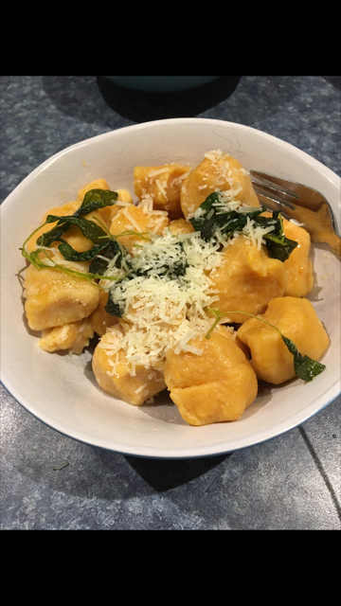
7. Bring a large saucepan of salted water to the boil. Drop in as many gnocchi as will fit in easily in one layer. Boil for 3 – 4 mins until the gnocchi rise to the surface. Lift out with slotted spoon and place on a clean baking tray or in a bowl. Reserve ½ cup of cooking liquid.
8. Prepare sauce (Butter and Sage)
9. Toss cooked gnocchi, reserved cooking liquid and butter sage sauce. Serve with grated parmesan.

